CLOUD SERVICE MODELS: IAAS, PAAS, SAAS
Cloud computing services are categorized into three primary models based on the level of control, flexibility, and responsibility shared between the service provider and the user: Infrastructure as a Service (IaaS), Platform as a Service (PaaS), and Software as a Service (SaaS).

Infrastructure as a Service (IaaS) Definition:
Infrastructure as a Service (IaaS) is a cloud computing model that provides virtualized
computing resources over the internet, including virtual machines, storage, and networking components. It eliminates the need for organizations to invest in and maintain physical
hardware such as servers and data centers. IaaS offers a highly flexible environment where
users can configure and manage operating systems, install applications, and control data. This model is ideal for organizations that require full control over their infrastructure while
benefiting from the scalability and cost efficiency of cloud services.

Responsibilities:
- User manages: Operating system, applications, and data
- Provider manages: Physical infrastructure and networking

Example:
A company uses Microsoft Azure Virtual Machines to deploy and run business applications without purchasing physical servers.

Advantages:
- High flexibility and customization
- Scalable and cost-effective infrastructure
- Full control over environment

Disadvantages:
- Requires technical expertise
- Security and maintenance responsibility on user
- Configuration complexity

Platform as a Service (PaaS)
Definition:
Platform as a Service (PaaS) is a cloud computing model that provides a complete
development and deployment environment in the cloud. It includes tools, frameworks, runtime environments, and services required for application development. PaaS allows developers to focus on writing code and building applications without worrying about
managing underlying infrastructure such as servers, operating systems, or storage. This model accelerates application development, simplifies deployment, and improves productivity by offering pre-configured environments and integrated development tools.

Responsibilities:
  - User manages: Applications and data
  - Provider manages: Operating system, runtime, and infrastructure

Example:
A development team uses Azure App Service to build, test, and deploy applications efficiently.

Advantages:
  - Faster development and deployment
  - No infrastructure management required
  - Built-in development tools and services

Disadvantages:
  - Limited control over platform
  - Vendor lock-in risk
  - Less flexibility for customization

Software as a Service (SaaS) Definition:
Software as a Service (SaaS) is a cloud computing model where fully functional software applications are delivered over the internet on a subscription basis. Users can access these applications through a web browser without the need for installation, configuration, or
maintenance. The service provider manages everything, including infrastructure, application updates, security, and data storage. SaaS is widely used for business applications such as email, customer relationship management (CRM), and office productivity tools, making it the most user-friendly and accessible cloud model.

Responsibilities:
  - User manages: Usage and access
  - Provider manages: Application, infrastructure, and maintenance

Example:
Employees use Microsoft 365 (Word, Excel, Outlook) directly via the internet.

Advantages:
  - Easy to use and access
  - No installation or maintenance required
  - Cost-effective subscription model

Disadvantages:
  - Limited customization
  - Data security concerns
  - Dependence on internet connectivity

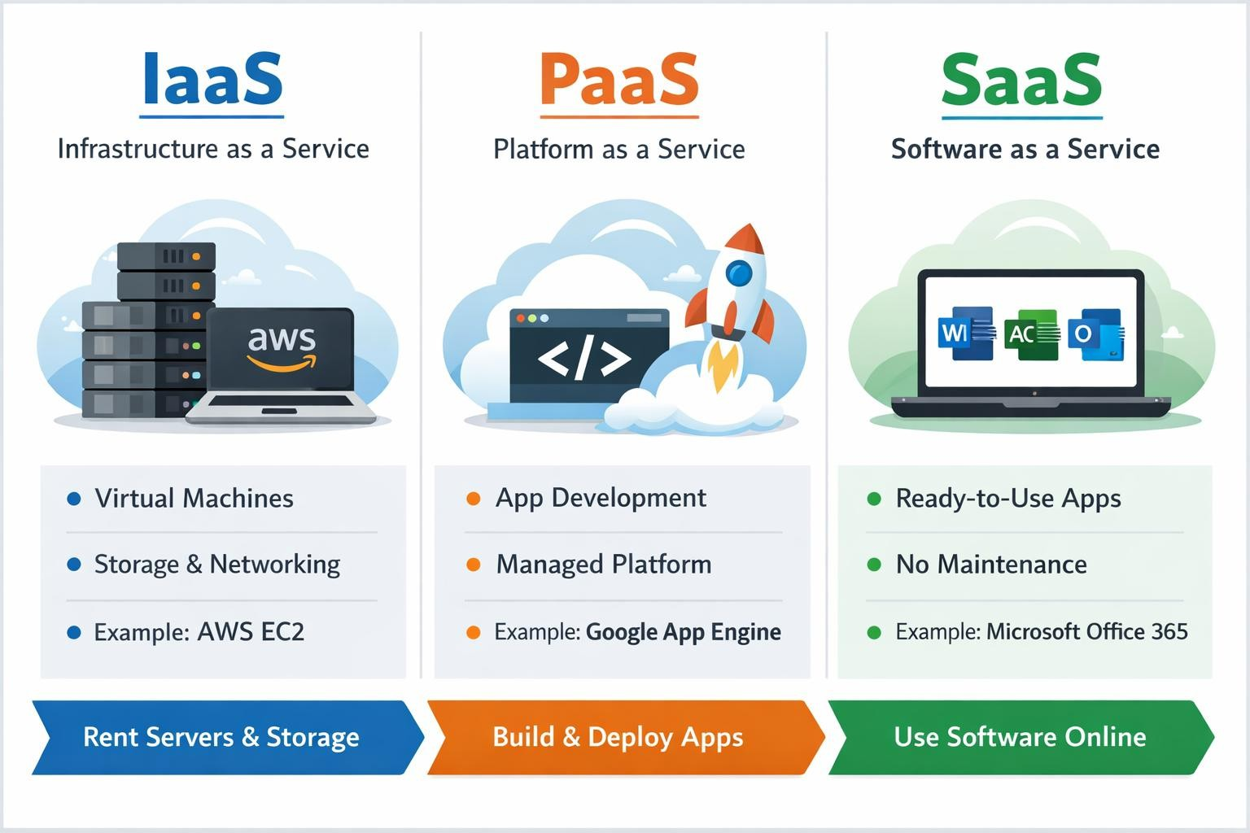

Key Takeaway
  - IaaS → Maximum control and flexibility
  - PaaS → Simplified development with moderate control
  - SaaS → Ease of use with minimal control
Organizations often adopt a combination of these models to meet different business and technical requirements.

